Ansible Assignment-3

Write a ansible playbook with module where install docker, docker compose. Create tomcat container and with your own network and deploy war file in it.
Docker and docker compose modules are available

- Ansible playbook – On workstation
Target1.yaml
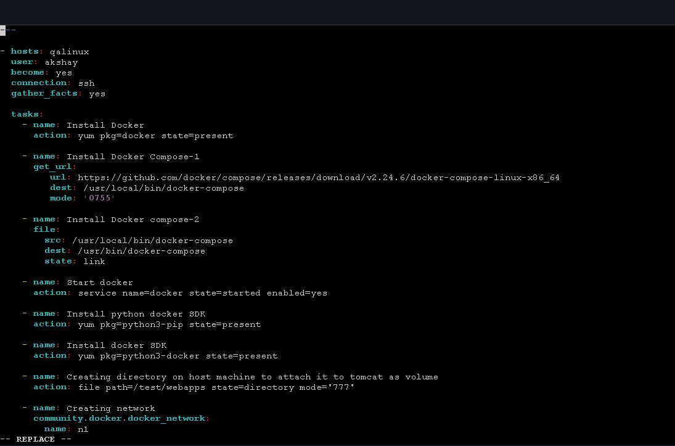
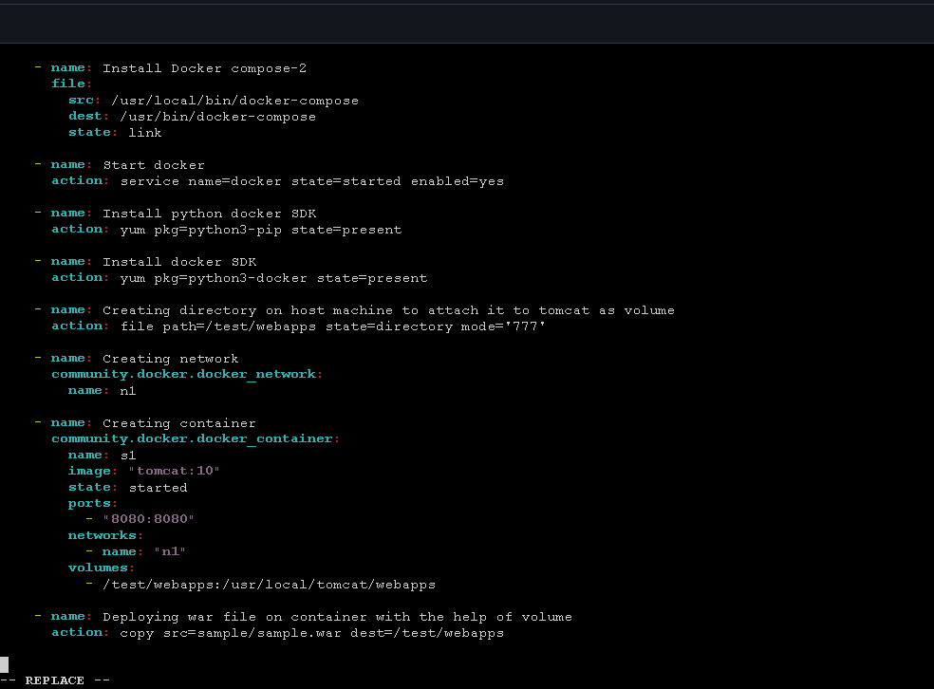

- output:
